# Using The Cellular Automaton (CA) To Model The Spread Of Dandelion

The Principle Of The Cellular Automaton (CA)

元胞自动机是一种用于模拟复杂系统（尤其是那些表现出涌现行为的系统）的计算模型。其模型在空间和时间上是离散的，由一个细胞网格组成，个体细胞可以处于多种状态之一。这些细胞基于一组规则在离散的时间步长内演化，这些规则决定了细胞的状态如何根据其相邻细胞的状态而变化。

Cellular Automaton are computational models used to simulate the complex systems, especially those exhibit with emergent behaviors. Their dimensions and time are discrete, consisting of a grid of cells, each of which can be in one of multiple states. These cells evolve over discrete time steps based on a set of rules that determine how a cell’s state changes based on the states of its neighboring cells.

Elements Consistence And Construction

1. Four Elementary Parameters :
   1. The Discrete N-Dimensional Cellular Grid

We can have one-dimensional, two-dimensional, … , n-dimensional CA. The atomic components of the lattice can be differently shaped: for example, a 2D lattice can be composed of triangles, squares, or hexagons. Usually homogeneity is assumed: all cells are qualitatively identical.

* 1. The Discrete States

At each discrete time step, each cell is in one and only one state.

* 1. Local Interactions

Each cell’s behavior depends only on what happens within its local neighborhood of cells (which may or may not include the cell itself). Lattices with the same basic topology may have different definitions of neighborhood, as we will see below. It is crucial, however, to note that “actions at a distance” are not allowed.

* 1. The Discrete Dynamics

The Reference To The Codes :

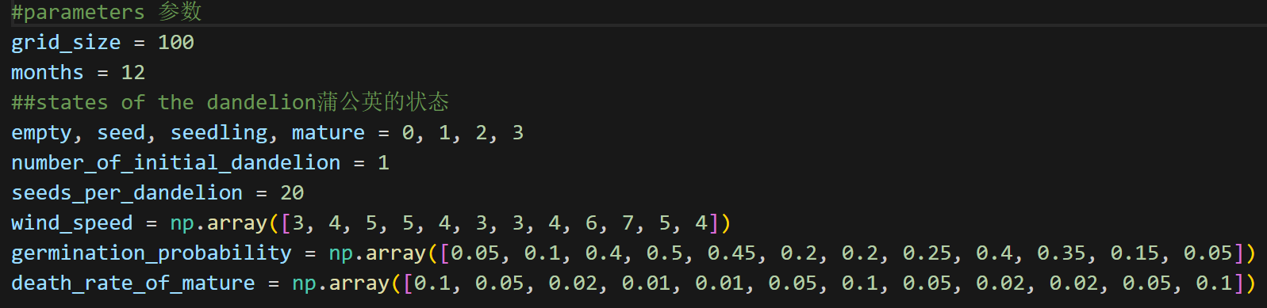

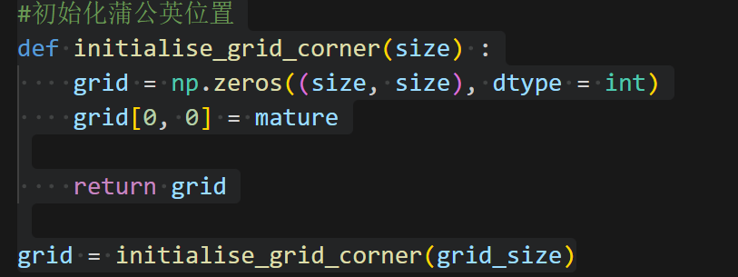

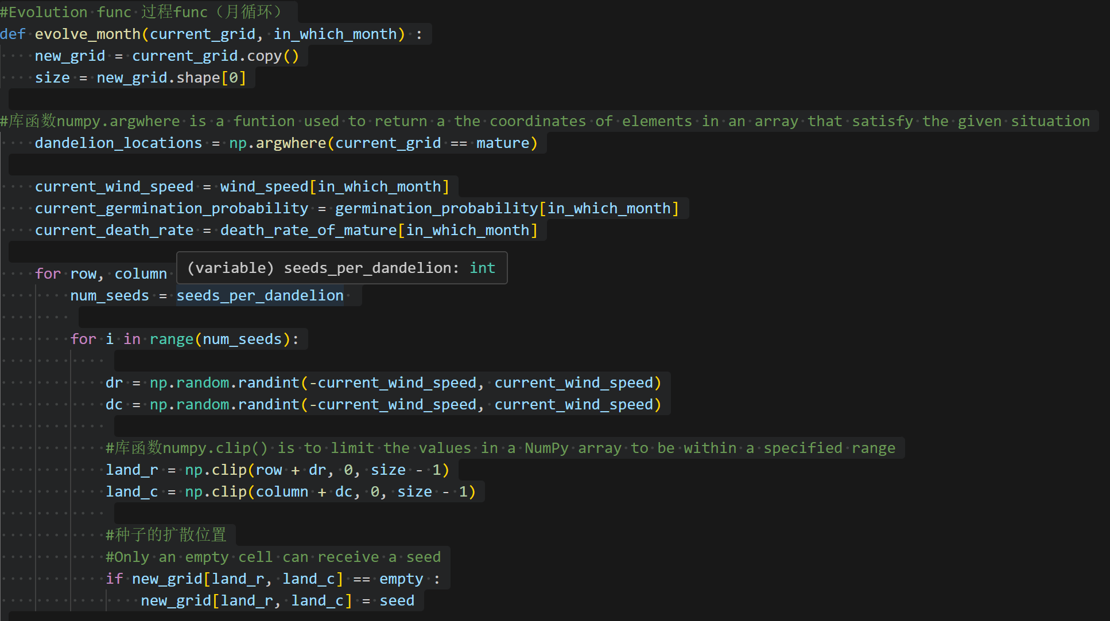

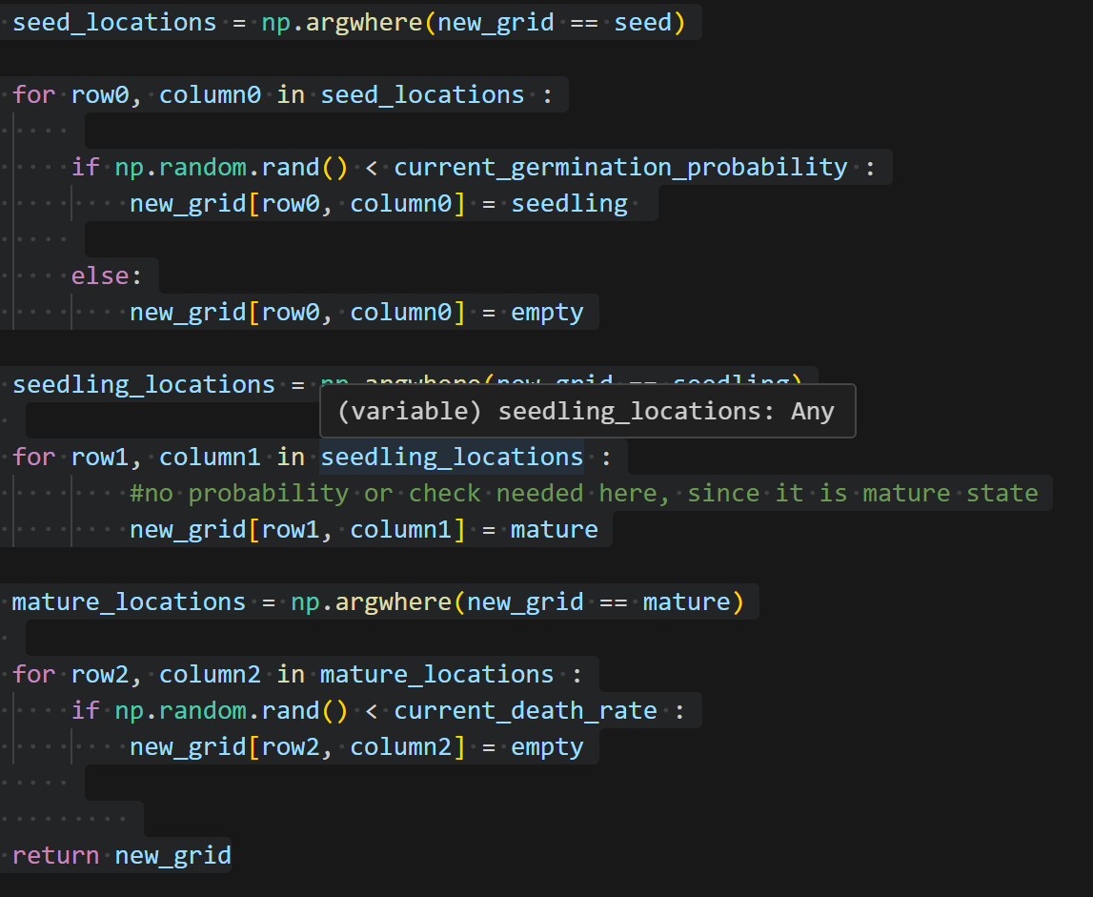

1. Key Difference With Classical: Non-Local Effect (Dispersal)

It's important to note the nature of your interaction:

* 1. Standard CA: The neighborhood is typically the 4-8 immediately adjacent cells (e.g., von Neumann or Moore neighborhood)
  2. My Model (Dispersal): The rule for a cell becoming a seed depends on finding a mature plant anywhere within a square of size (2 * win_speed) * (2 * win_speed) centered on the mature plant.

Reference To the Codes :



The Final Result Diagrams ( 3 Times)

